**UML DAIGRAM**

BATCH-14 ( JOB PORTAL ) 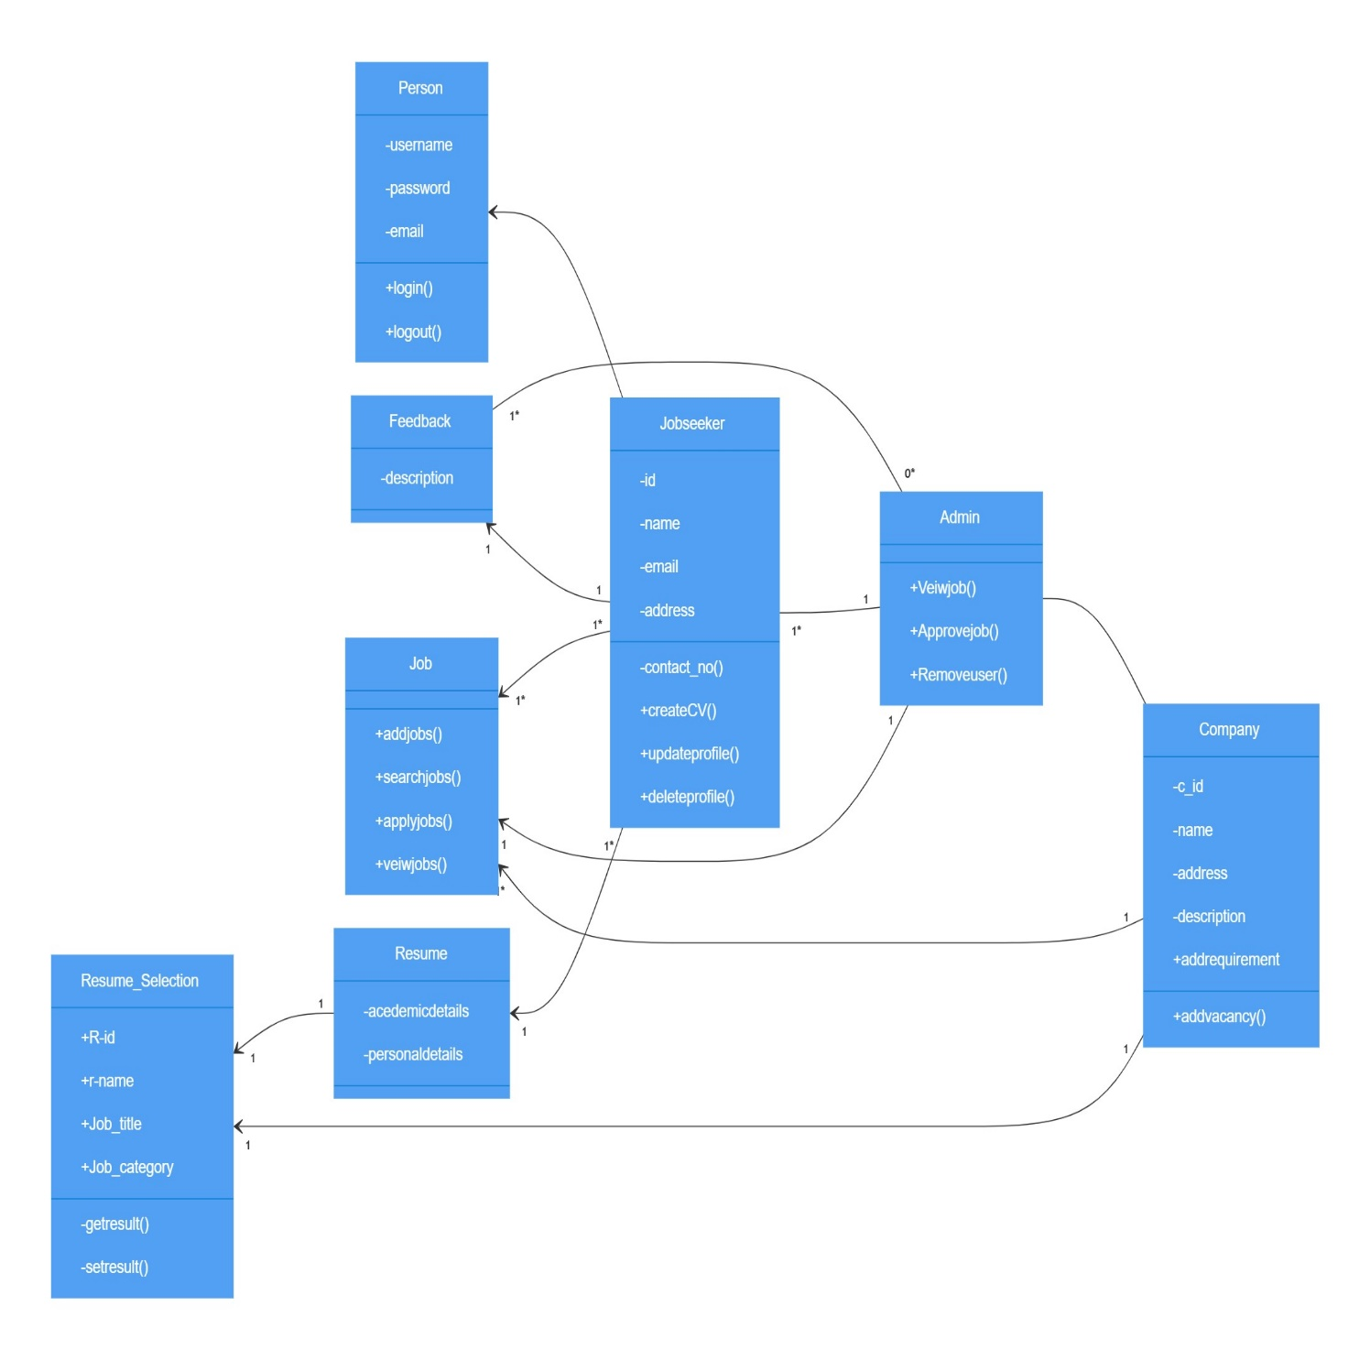

**Classes and Attributes**:

**Person:**

Attributes: Username, Password

Methods: login(), logout()

**admin :**

Methods: ViewJobs(), ApproveJobs(), RemoveUser()

**Jobseeker :**

Attributes: id, Name, Address, Email_ID, Contact_No

Methods: CreateCV(), UpdateProfile(), DeleteProfile()

**company:**

Attributes: c_id, name, address, description

Methods: AddVacancy(), AddRequirement()

**Feedback:**

Attributes: Description

**Job:**

Methods: AddJobs(), SearchJobs(), ApplyJobs(), ViewJobs()

**Resume:**

Attributes: academicDetails, PersonalDetails

**Relationships:**

The admin manages Jobseekers ( admin to Jobseeker with a 1…n ).

Admin approves Feedback ( admin to Feedback with 1 multiplicity).

Jobseekers apply to Jobs (Jobseeker to Job with 1…n multiplicity).

Companies perform Resume Selection (Resume with 1 multiplicity).